**Azure Demo project**

**On-Premises**

**Azure**

**Scheduler Task/Triggers**

**Source - SQL**

**Excel**

**Data factory**

**Storage**

**Linked Server-Source**

**Linked Server-Sink**

**Raw**

**Process**

**Curated**

**Data Bricks**

**Endra ID**

**Visualization**

**(Power BI)**

**Access Key**

**SHIR**

**SHIR Task/Triggers**

**ETL**

**ETL**

Sample Excel data: Configuration &Value

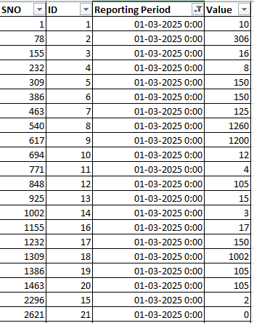

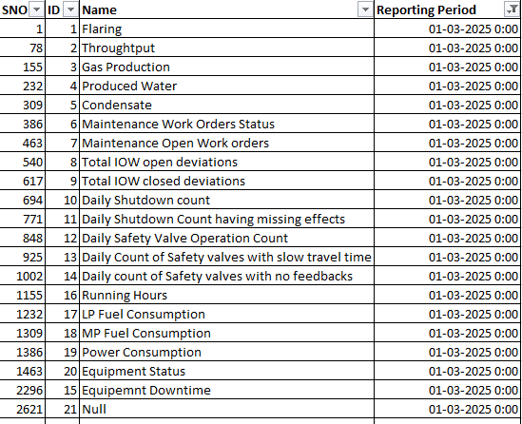

**SQL Server Authentication Mode:**

